# Help Document for Healthcare Sentimental Analysis

Step 1:

* Open the “sentiment_predict.sln” solution in the visual studio.

Step 2:

* Add environment
* 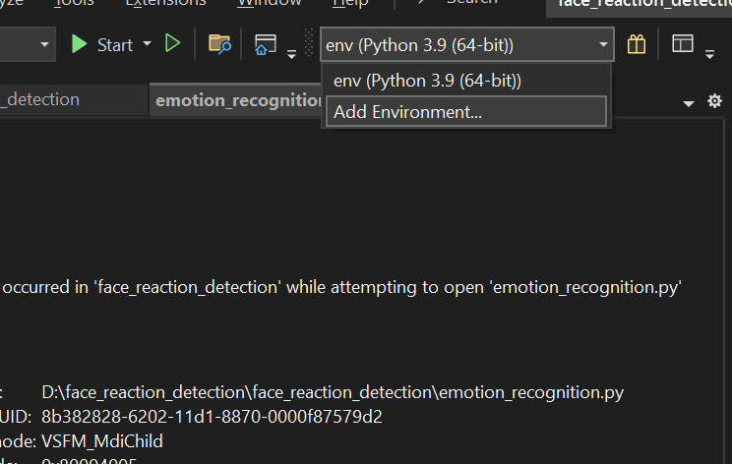
* Create the virtual environment as the below diagram
* A screenshot of a computer

  Description automatically generated
* In the python environment select the “packages(pypi)”
* A screenshot of a computer program

  Description automatically generated
* In the search column install the required libraries
* Copy pastes the names and install that “numpy”, “scikit-learn”,”matplotlib”,”pandas”,” seaborn”,” wordcloud”,” nltk”.
* A screenshot of a computer program

  Description automatically generated

Step3:

* Now You can **Run** the Program.